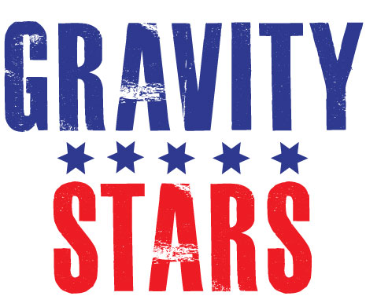
PRESS RELEASE – EFFECTIVE IMMEDIATELY – 18/01/13
Gravity Stars Partners with FMX Pioneers The Crusty Demons of Dirt Exclusively Throughout Asia

Gravity Stars are honoured and excited to announce a major partnership with freestyle moto-x (FMX) pioneers the Crusty Demons of Dirt. Special thanks goes to Gravity Stars’ David Murray, Kieran Wicks, Colin Seegar and Damien Reilly for putting the agreement together with Crusty Demons founder Jon Freeman and Chief of Operations Marc Levine.

Anyone who is anyone in the FMX world has risen through Crusty’s ranks. Nearly two decades ago Crusty brought the crazy world of FMX to lounge rooms across the world through the release of their acclaimed series of films that showcased the elite of FMX performing death defying stunts. The origins of the group can be traced to 1994, when filmmakers Jon Freeman and Dana Nicholson had been accumulating footage to showcase a behind the scenes expose of the lifestyle of an American pro motocross rider in action, featuring 145 ft. plus jumps, 45 ft. high in the air soaring over sand dunes, mountains, houses, buses and anything else secure and steep enough to hold the weight of bike and rider. The end result was Fleshwound Films and the first video Crusty Demons of Dirt.
Fleshwound Films spent two years gathering footage. Following the success of the first film, Crusty 2 was premiered 18 months later. Sales exceeded expectations and tripled from the first video as the Crusty phenomenon began spreading worldwide. Crusty Demons of Dirt developed a live stadium spectacular that features the world’s best FMX riders performing the outlandish extreme sports stunts that they are now world famous for, touring the show internationally.
Gravity Stars have secured the exclusive Asian touring rights for the Crusty Demons and are now developing a rebranded stadium spectacular for Asia and the Middle East. Gravity Stars are strategically placed throughout Asia and will be working with the regions premier promoters. Our vision is to develop the Gravity Stars/Crusty Demons show, whilst at the same time developing the Gravity Stars technology to be a leading edge marketing platform, making Gravity Stars a household name in world class entertainment throughout Asia and the globe.
Gravity Stars will produce an international touring road-show supported by a marketing platform with cutting edge data technology. Combining music concerts with unique marketing initiatives and loyalty rewards, moto-X and associated extreme sports events, creates an intoxicating mix in countries where the predominant form of transport is small motor cycles in the same size bracket. There have been one-off shows here and there, but no real name or leader in touring events throughout Asia. Gravity Stars saw this opportunity that wasn’t being satisfied in the market where over 80% of the world’s motorbike riders live and 90% of the motorbike manufacturing occurs, from this environment Gravity Stars was born!
The concept is simple, recruit the world elite of extreme sports and music and then create exceptionally vibrant, multisensory events that combine stunning visuals and music with extreme sports contests/demonstrations. Gravity Stars is a highly dynamic, experienced team armed with, state of the art e-commerce, data-mining, content-incentive (music voucher), social media, reporting and ticketing technology. We also boast a who’s who A-List network of athletes, entertainers and industry executives, making Gravity Stars an ominous force in the business of extreme sports and music events throughout Asia.
Crusty Demons & Taublieb films are currently in the midst of producing a documentary with Monster Energy Drinks on the History of Freestyle Motocross (FMX). Gravity Stars are excited about adding the next chapter with Crusty as FMX takes over Asia. Gravity Stars are a constantly expanding force in the music/extreme sports promotions business, essentially inventing new levels for extreme sports touring shows and business models. Masters of innovation, the Gravity Stars team are at the frontier as true pioneers in the fastest growing sector of world sports today.

For further information please contact Kieran Wicks – COO – Gravity Stars USA LLC
E: Kieran@gravitystars.com

********************************************************************************
ABOUT GRAVITY STARS:
www.gravitystars.com
Gravity Stars are boutique entertainment brokers and event management specialists, bringing extreme sport’s most elite athletes to the global market. Gravity Stars foresees itself to be the premier brand name in major events that combine music with extreme sports.
Opportunistic by nature, the Gravity Stars team develops new market opportunities for its global client and partner network. Gravity Stars us a constantly expanding force in the music/extreme sports promotions business and marketing, essentially inventing new levels for extreme sports touring shows and business models. Masters of innovation, the Gravity Stars team are in the frontier as true pioneers in the fastest growing sector of world sports today!
Gravity Stars THE trend setter, specialising in extreme sports and music festivals, which offer live music, extreme sports demonstrations / competitions, athlete autograph sessions and interactive elements featuring the world’s most elite athletes and cutting edge musicians, providing event participants and concert goers with a unique, rich and rewarding experience.
************************************************************************
Contact Details:

Gravity Stars USA LLC
Press and Media Manager
Unit 20 No 112 McEvoy Street
Alexandria NSW 2015
P: + 61 2 9310 0155
F: + 61 2 9310 0166
E: sales@gravitystars.com
W: www.gravitystars.com

************************************************************************

Search on 'gravity stars' in Google for more information.
***END***

